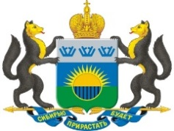
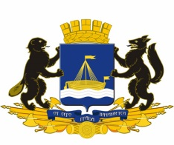

GOVERNMENT  OF TYUMEN REGION  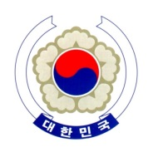 | ADMINISTRATION  OF TYUMEN CITY | TRADE OFFICE  KOREA EMBASSY IN RUSSIA | KOREA INTERNATIONAL TRADE AGENCY

HONORARY CONSUL
OF REPJUBLIC OF KOREA
TO TYUMEN

PROGRAM
RUSSIA-KOREA
INDUSTRIAL EXPO

«Global cooperation – basis for high technologies»

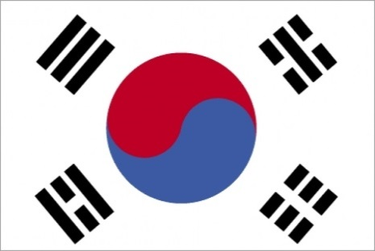

Tyumen – 2020
EXPO Goals and Tasks

Goals: presentation of industrial potential of Korean and Russian companies, organization of effective networking and business talks between Russian and Korean businesses, and government officials for enhancing productivity of Russia-Korea regional cooperation.

Tasks:
- outline prospects and potential for cooperation development between Tyumen region and Republic of Korea;
- exchange of experience technologies between Russian and Korean companies;
- insight into Tyumen region potential

Venue: Tyumen, Sevastopolskaya St., 12

Core audience:
• top managers, marketing executives from Tyumen region and Republic of Korea;
• educational representatives from Tyumen region and Republic of Korea;
• high ranking government officials and experts from Tyumen region and Republic of Korea

Organizational issues:
Period: 2-3 days
Participation: free, invitation
Handout materials: bilingual, free, upon registration
Expenses: participants cover travel and accommodation expenses
Meals: coffee breaks

Pavilions lay out:

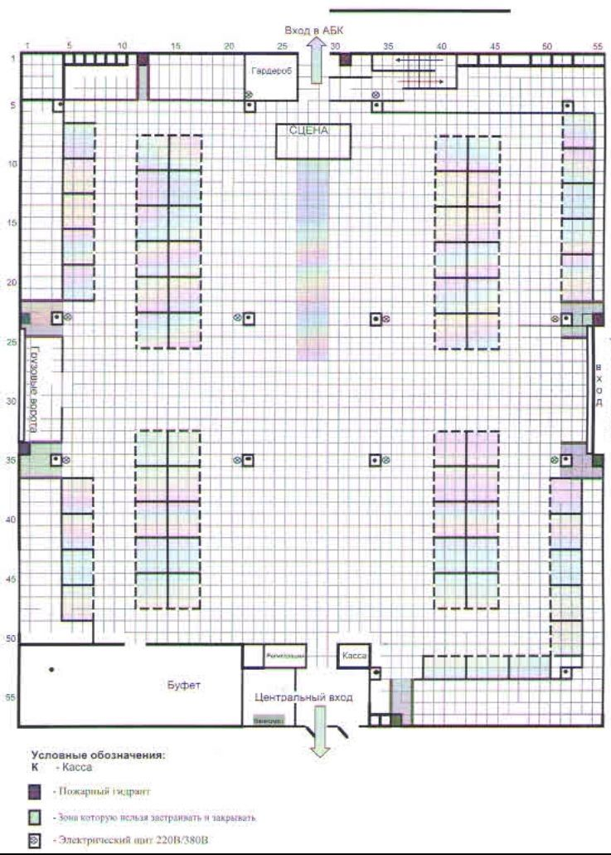

26th May 2020
 | Arrival of participants for Russia-Korea Industrial EXPO in Tyumen
27th May 2020
09:30-10:00 | Registration  Venue: Tyumen Fair, Tyumen, Sevastopolskaya St., 12
10.00-11.00 | Opening ceremony  - from the Russian side: Tyumen Governor Alexander Moor  - from Korean side: Ambassador Extraordinary and Plenipotentiary of the Republic of Korea to the Russian Federation Lee Seokbae
11.00-12.30 | EXPO tour
13.00-14.00 | Lunch
14.00-16.00 | Round table «Bilateral cooperation in machine-building and high technologies»
16.00-18.00 | Tyumen city tour  (for Korean representatives)
28th May 2020
09:30-10:00 | Registration  Venue: Tyumen Fair, Tyumen, Sevastopolskaya St., 12
10.00-12.00 | Summit of Russia and Korea universities «International integration in education»
13.00-14.00 | Lunch
14.00-16.00 | Round table «Prospects of Russia-Korea inter-regional agriculture cooperation»
16.00-18.00 | Onsite tour of Tyumen industrial sites  (for Korean representatives)
29th May 2020
09:30-10:00 | Registration  Venue: Tyumen Fair, Tyumen, Sevastopolskaya St., 12
10.00-12.00 | Seminar on cooperation in healthcare
14.00 | Closing ceremony
16.00-20.00 | Concert  Venue: «Siberia Golden Gates», Tyumen Gertsena St., 87

